**pom.xml:**

<?xml version="1.0" encoding="UTF-8"?>

<project xmlns="http://maven.apache.org/POM/4.0.0" xmlns:xsi="http://www.w3.org/2001/XMLSchema-instance"

xsi:schemaLocation="http://maven.apache.org/POM/4.0.0 https://maven.apache.org/xsd/maven-4.0.0.xsd">

<modelVersion>4.0.0</modelVersion>

<parent>

<groupId>org.springframework.boot</groupId>

<artifactId>spring-boot-starter-parent</artifactId>

<version>3.5.3</version>

<relativePath/> <!-- lookup parent from repository -->

</parent>

<groupId>com.cognizant</groupId>

<artifactId>spring-learn</artifactId>

<version>0.0.1-SNAPSHOT</version>

<name>spring-learn</name>

<description>Demo project for Spring Boot</description>

<url/>

<licenses>

<license/>

</licenses>

<developers>

<developer/>

</developers>

<scm>

<connection/>

<developerConnection/>

<tag/>

<url/>

</scm>

<properties>

<java.version>17</java.version>

</properties>

<dependencies>

<dependency>

<groupId>org.springframework.boot</groupId>

<artifactId>spring-boot-starter-web</artifactId>

</dependency>

<dependency>

<groupId>org.springframework.boot</groupId>

<artifactId>spring-boot-devtools</artifactId>

<scope>runtime</scope>

<optional>true</optional>

</dependency>

<dependency>

<groupId>org.springframework.boot</groupId>

<artifactId>spring-boot-starter-test</artifactId>

<scope>test</scope>

</dependency>

</dependencies>

<build>

<plugins>

<plugin>

<groupId>org.springframework.boot</groupId>

<artifactId>spring-boot-maven-plugin</artifactId>

</plugin>

</plugins>

</build>

</project>

**1. spring-rest-handson**

**Create a Spring Web Project using Maven**

**CODE:**

**SpringLearnApplication.java:**

package com.cognizant.spring_learn;

import org.springframework.boot.SpringApplication;

import org.springframework.boot.autoconfigure.SpringBootApplication;

@SpringBootApplication

public class SpringLearnApplication {

public static void main(String[] args) {

SpringApplication.*run*(SpringLearnApplication.class, args);

System.*out*.println("SpringLearnApplication started...");

}

}

**OUTPUT:**

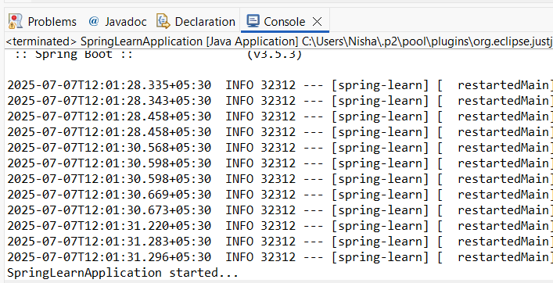

**Spring Core – Load Country from Spring Configuration XML**

**CODE:**

**SpringLearnApplication.java:**

package com.cognizant.spring_learn;

import org.slf4j.Logger;

import org.slf4j.LoggerFactory;

import org.springframework.context.ApplicationContext;

import org.springframework.context.support.ClassPathXmlApplicationContext;

public class SpringLearnApplication {

private static final Logger *LOGGER* = LoggerFactory.*getLogger*(SpringLearnApplication.class);

public static void main(String[] args) {

*displayCountry*();

}

public static void displayCountry() {

ApplicationContext context = new ClassPathXmlApplicationContext("country.xml");

Country country = context.getBean("country", Country.class);

*LOGGER*.debug("Country : {}", country.toString());

}

}

**Country.java:**

package com.cognizant.spring_learn;

import org.slf4j.Logger;

import org.slf4j.LoggerFactory;

public class Country {

private static final Logger *LOGGER* = LoggerFactory.*getLogger*(Country.class);

private String code;

private String name;

public Country() {

*LOGGER*.debug("Inside Country Constructor.");

}

public String getCode() {

*LOGGER*.debug("Getting Country Code.");

return code;

}

public void setCode(String code) {

*LOGGER*.debug("Setting Country Code.");

this.code = code;

}

public String getName() {

*LOGGER*.debug("Getting Country Name.");

return name;

}

public void setName(String name) {

*LOGGER*.debug("Setting Country Name.");

this.name = name;

}

@Override

public String toString() {

return "Country [code=" + code + ", name=" + name + "]";

}

}

**country.xml:**

<?xml version="1.0" encoding="UTF-8"?>

<beans xmlns="http://www.springframework.org/schema/beans"

xmlns:xsi="http://www.w3.org/2001/XMLSchema-instance"

xsi:schemaLocation="

http://www.springframework.org/schema/beans

http://www.springframework.org/schema/beans/spring-beans.xsd">

<bean id="country" class="com.cognizant.spring_learn.Country">

<property name="code" value="IN" />

<property name="name" value="India" />

</bean>

</beans>

**logback.xml:**

<?xml version="1.0" encoding="UTF-8"?>

<configuration>

<appender name="STDOUT" class="ch.qos.logback.core.ConsoleAppender">

<encoder>

<pattern>%d{HH:mm:ss.SSS} %-5level %logger{36} - %msg%n</pattern>

</encoder>

</appender>

<root level="DEBUG">

<appender-ref ref="STDOUT"/>

</root>

</configuration>

**OUTPUT:**

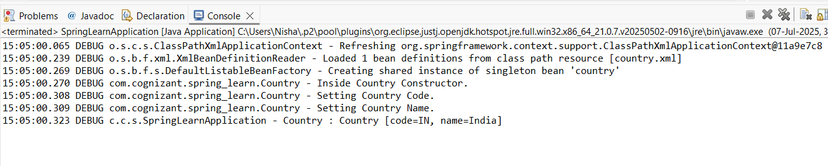

**2. spring-rest-handson**

**SpringLearnApplication.java:**

package com.cognizant.spring_learn;

import org.springframework.boot.SpringApplication;

import org.springframework.boot.autoconfigure.SpringBootApplication;

@SpringBootApplication

public class SpringLearnApplication {

public static void main(String[] args) {

SpringApplication.*run*(SpringLearnApplication.class, args);

}

}

**Hello World RESTful Web Service**

**CODE:**

**HelloController.java:**

package com.cognizant.spring_learn.controller;

import org.slf4j.Logger;

import org.slf4j.LoggerFactory;

import org.springframework.web.bind.annotation.GetMapping;

import org.springframework.web.bind.annotation.RestController;

@RestController

public class HelloController {

private static final Logger *LOGGER* = LoggerFactory.*getLogger*(HelloController.class);

@GetMapping("/hello")

public String sayHello() {

*LOGGER*.info("START - sayHello()");

String message = "Hello World!!";

*LOGGER*.info("END - sayHello()");

return message;

}

}

**OUTPUT:**

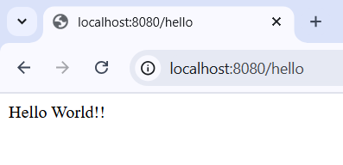

**REST - Country Web Service**

**CODE:**

**Country.java:**

package com.cognizant.spring_learn.model;

public class Country {

private String code;

private String name;

public Country() {}

public Country(String code, String name) {

this.code = code;

this.name = name;

}

public String getCode() {

return code;

}

public void setCode(String code) {

this.code = code;

}

public String getName() {

return name;

}

public void setName(String name) {

this.name = name;

}

}

**country.xml:**

<?xml version="1.0" encoding="UTF-8"?>

<beans xmlns="http://www.springframework.org/schema/beans"

xmlns:xsi="http://www.w3.org/2001/XMLSchema-instance"

xsi:schemaLocation="http://www.springframework.org/schema/beans

http://www.springframework.org/schema/beans/spring-beans.xsd">

<bean id="in" class="com.cognizant.spring_learn.model.Country">

<property name="code" value="IN"/>

<property name="name" value="India"/>

</bean>

</beans>

**CountryController.java:**

package com.cognizant.spring_learn.controller;

import com.cognizant.spring_learn.model.Country;

import org.slf4j.Logger;

import org.slf4j.LoggerFactory;

import org.springframework.context.ApplicationContext;

import org.springframework.context.support.ClassPathXmlApplicationContext;

import org.springframework.web.bind.annotation.RequestMapping;

import org.springframework.web.bind.annotation.RestController;

@RestController

public class CountryController {

private static final Logger *LOGGER* = LoggerFactory.*getLogger*(CountryController.class);

@RequestMapping("/country")

public Country getCountryIndia() {

*LOGGER*.info("START - getCountryIndia()");

ApplicationContext context = new ClassPathXmlApplicationContext("country.xml");

Country country = (Country) context.getBean("in");

*LOGGER*.info("END - getCountryIndia()");

return country;

}

}

**OUTPUT:**

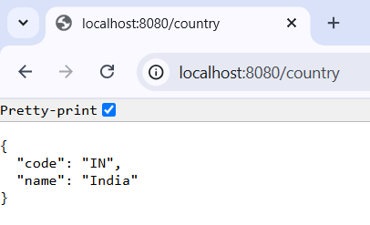

**REST - Get country based on country code**

**CODE:**

**CountryController.java:**

package com.cognizant.spring_learn.controller;

import com.cognizant.spring_learn.model.Country;

import com.cognizant.spring_learn.service.CountryService;

import org.slf4j.Logger;

import org.slf4j.LoggerFactory;

import org.springframework.beans.factory.annotation.Autowired;

import org.springframework.web.bind.annotation.*;

@RestController

public class CountryController {

private static final Logger *LOGGER* = LoggerFactory.*getLogger*(CountryController.class);

@Autowired

private CountryService countryService;

@GetMapping("/countries/{code}")

public Country getCountry(@PathVariable String code) {

*LOGGER*.info("START - getCountry({})", code);

Country country = countryService.getCountry(code);

*LOGGER*.info("END - getCountry()");

return country;

}

}

**CountryService.java:**

package com.cognizant.spring_learn.service;

import com.cognizant.spring_learn.model.Country;

import org.springframework.context.ApplicationContext;

import org.springframework.context.support.ClassPathXmlApplicationContext;

import org.springframework.stereotype.Service;

import java.util.List;

@Service

public class CountryService {

public Country getCountry(String code) {

ApplicationContext context = new ClassPathXmlApplicationContext("country.xml");

List<Country> countryList = (List<Country>) context.getBean("countryList");

return countryList.stream()

.filter(c -> c.getCode().equalsIgnoreCase(code))

.findFirst()

.orElse(null);

}

}

**country.xml:**

<?xml version="1.0" encoding="UTF-8"?>

<beans xmlns="http://www.springframework.org/schema/beans"

xmlns:xsi="http://www.w3.org/2001/XMLSchema-instance"

xsi:schemaLocation="http://www.springframework.org/schema/beans

http://www.springframework.org/schema/beans/spring-beans.xsd">

<bean id="in" class="com.cognizant.spring_learn.model.Country">

<property name="code" value="IN"/>

<property name="name" value="India"/>

</bean>

<bean id="countryList" class="java.util.ArrayList">

<constructor-arg>

<list>

<bean class="com.cognizant.spring_learn.model.Country">

<property name="code" value="IN"/>

<property name="name" value="India"/>

</bean>

<bean class="com.cognizant.spring_learn.model.Country">

<property name="code" value="US"/>

<property name="name" value="United States"/>

</bean>

<bean class="com.cognizant.spring_learn.model.Country">

<property name="code" value="DE"/>

<property name="name" value="Germany"/>

</bean>

<bean class="com.cognizant.spring_learn.model.Country">

<property name="code" value="JP"/>

<property name="name" value="Japan"/>

</bean>

</list>

</constructor-arg>

</bean>

</beans>

**OUTPUT:**

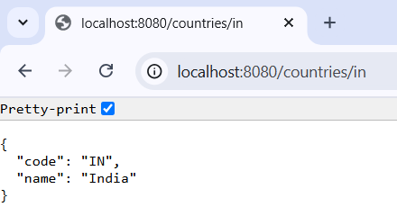

**5. JWT-handson**

**Create authentication service that returns JWT**

**CODE:**

**pom.xml:**

<?xml version="1.0" encoding="UTF-8"?>

<project xmlns="http://maven.apache.org/POM/4.0.0" xmlns:xsi="http://www.w3.org/2001/XMLSchema-instance"

xsi:schemaLocation="http://maven.apache.org/POM/4.0.0 https://maven.apache.org/xsd/maven-4.0.0.xsd">

<modelVersion>4.0.0</modelVersion>

<parent>

<groupId>org.springframework.boot</groupId>

<artifactId>spring-boot-starter-parent</artifactId>

<version>3.5.3</version>

<relativePath/> <!-- lookup parent from repository -->

</parent>

<groupId>com.cognizant</groupId>

<artifactId>spring-learn</artifactId>

<version>0.0.1-SNAPSHOT</version>

<name>spring-learn</name>

<description>Demo project for Spring Boot</description>

<url/>

<licenses>

<license/>

</licenses>

<developers>

<developer/>

</developers>

<scm>

<connection/>

<developerConnection/>

<tag/>

<url/>

</scm>

<properties>

<java.version>17</java.version>

</properties>

<dependencies>

<dependency>

<groupId>org.springframework.boot</groupId>

<artifactId>spring-boot-starter-web</artifactId>

</dependency>

<dependency>

<groupId>org.springframework.boot</groupId>

<artifactId>spring-boot-starter-test</artifactId>

<scope>test</scope>

</dependency>

<!-- JWT API -->

<dependency>

<groupId>io.jsonwebtoken</groupId>

<artifactId>jjwt-api</artifactId>

<version>0.11.5</version>

</dependency>

<!-- Runtime implementation -->

<dependency>

<groupId>io.jsonwebtoken</groupId>

<artifactId>jjwt-impl</artifactId>

<version>0.11.5</version>

<scope>runtime</scope>

</dependency>

<!-- JSON parser support -->

<dependency>

<groupId>io.jsonwebtoken</groupId>

<artifactId>jjwt-jackson</artifactId>

<version>0.11.5</version>

<scope>runtime</scope>

</dependency>

</dependencies>

<build>

<plugins>

<plugin>

<groupId>org.springframework.boot</groupId>

<artifactId>spring-boot-maven-plugin</artifactId>

</plugin>

</plugins>

</build>

</project>

**JwtUtil.java:**

package com.cognizant.spring_learn.security;

import io.jsonwebtoken.Jwts;

import io.jsonwebtoken.SignatureAlgorithm;

import io.jsonwebtoken.security.Keys;

import org.springframework.stereotype.Component;

import java.security.Key;

import java.util.Date;

@Component

public class JwtUtil {

private final Key key = Keys.*secretKeyFor*(SignatureAlgorithm.*HS256*);

private final long expiryDuration = 60 * 60 * 1000; // 1 hour

public String generateToken(String username) {

return Jwts.*builder*()

.setSubject(username)

.setIssuedAt(new Date())

.setExpiration(new Date(System.*currentTimeMillis*() + expiryDuration))

.signWith(key)

.compact();

}

}

**AuthController.java:**

package com.cognizant.spring_learn.security;

import jakarta.servlet.http.HttpServletRequest;

import org.springframework.beans.factory.annotation.Autowired;

import org.springframework.web.bind.annotation.*;

import java.util.Base64;

import java.util.HashMap;

import java.util.Map;

@RestController

public class AuthController {

@Autowired

private JwtUtil jwtUtil;

@RequestMapping(value = "/authenticate", method = RequestMethod.*GET*)

public Map<String, String> authenticate(HttpServletRequest request) {

String authHeader = request.getHeader("Authorization");

if (authHeader == null || !authHeader.startsWith("Basic ")) {

throw new RuntimeException("Missing or invalid Authorization header");

}

try {

String base64Credentials = authHeader.substring("Basic ".length()).trim();

byte[] credDecoded = Base64.*getDecoder*().decode(base64Credentials);

String credentials = new String(credDecoded);

// Debug log

System.*out*.println("Decoded credentials: " + credentials);

String[] values = credentials.split(":", 2);

if (values.length < 2) {

throw new RuntimeException("Invalid credential format. Expected 'username:password'");

}

String username = values[0];

String password = values[1];

if (!username.equals("user") || !password.equals("pwd")) {

throw new RuntimeException("Invalid credentials");

}

String token = jwtUtil.generateToken(username);

Map<String, String> response = new HashMap<>();

response.put("token", token);

return response;

} catch (IllegalArgumentException e) {

throw new RuntimeException("Failed to decode credentials: " + e.getMessage());

}

}

}

**OUTPUT:**

